Rushworth Community Taxi Service
Project Plan

1 Project Setup
1.1 Coordinator Recruitment
On successful application for funding for the taxi service an advertisement for a Coordinator was placed in the local paper as well as on various community recruitment forums. The position was for 20hrs per week for 6 months. A successful applicant in Damien Grigg was employed for the position. However due to some personal issues and the onset of Covid restrictions delaying the project he decided to forego his employment in the position without starting. Subsequently the position was readvertised, and Faye Moore filled the position for the next 6 months on a 10hr a week basis. It was changed to 10hr per week over a period of one year due to the delays and uncertainty of implementing the project within the 6-month timeline due to Covid19. Faye relinquished the position after 6 months and now Craig Seamer has taken up the position for the remaining 6 months of the project implementation phase.
1.2 Detailed Project Plan
A provisional project plan was developed in the form of a Gantt chart for the funding application (see below). This has been expanded and modified with extensive consultation with the Coordinators(s), Regional Association of Neighbourhood and Community Houses (RANCH) and representatives from the Department of Transport (DoT) to reflect these changes as well as interruptions to the project cycle caused by Covid19 however the project tasks and timelines for each task remain the same.
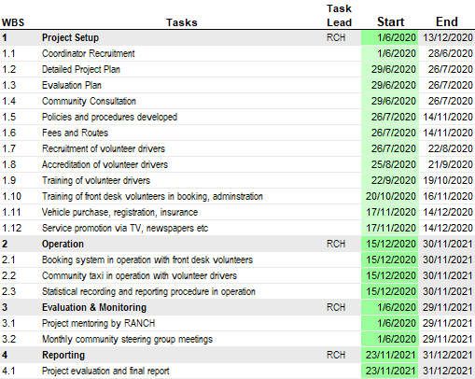

1.3 Evaluation Plan
Regional Association of Neighbourhood and Community Houses (RANCH) have been contracted to present an Evaluation Plan and write a Post Implementation Review of the project. An Evaluation Plan is provided in a separate document.
1.4 Community Consultation
The Rushworth Community House (RCH) prior to this project application conducted a survey of its clients who access and use the RCH medical transport service, on the need for a community taxi service. The survey found 100% of the respondents thought it a good idea to have a community transport service other than one which provides transport to medical appointments only.
There has also been extensive consultation with other community groups in the Rushworth area about the need, viability and nature of the community taxi service. These include the Lions Club, Goulburn Valley Health, Rushworth Events Inc., Senior Citizens, the Mens Shed, the Salvation Army and Campaspe Shire Council. All organisations have expressed that a community taxi in Rushworth is very much needed to address the lack of public transport and would support the implementation of a community taxi in any way they can.
In the later part of last year, a community survey was undertaken with the public asked on their preferences on the nature of the community taxi service with participants asked a range of questions on the preferred date and times of various routes and some indication of the price they were willing to pay. This survey was presented through an online site as well as hard copies distributed throughout local business and community groups in the taxi service catchment area. A good response was received with over 50 respondents filling out the survey. These results are shown graphically below and will form part of the basis for determining routes and fees for the service.

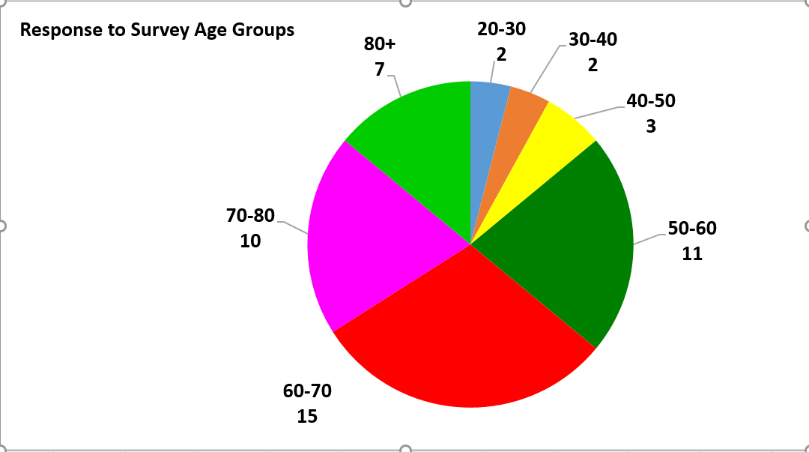

1.5 Fees and Routes
Initial consultation with the Steering Committee and various community organisations identified some initial routes for the taxi service. Initially, the service would likely conduct several regular trips with multiple passengers to Shepparton and Kyabram for shopping, family visits and a variety of professional appointments. Scheduled trips between Rushworth and nearby towns would also allow people to dine-out without worrying about driving and trips to and from Murchison East railway station are also being considered.
In combination with the community survey results these routes and fees will be modified to best suits community needs. It will be understood however that depending on the success or failure of the initial routes, modifications will probably need to be made and that routes will have to have a degree of flexibility around them to meet community needs. Also there will need to be consideration on the passenger fees charged depending on the destination along with a degree of reasonableness exercised, e.g. capped fares, so that people who are transport-disadvantaged or who are financially disadvantaged are not overburdened with the cost.
1.6 Policies and procedures developed
The medical transport service which currently is run by the RCH, has already in existence an extensive range of administrative policies and procedures which will be used to administer the community taxi service with some minor adjustments specific to the characteristics of the taxi service. These include:
- Driver Registration Procedure
- Driver Information and Instruction booklet
- Covid Cleaning Records (appendix 1)
- Driver Annual Checklist
- Code of Conduct
- Occupational Health and Safety Procedures
- Client Booking Procedure
- Trip Costs
- Complaints and Grievance Procedure
- Critical Incidents Procedure
- Privacy Policy
- Risk Assessment Map
In addition, or working in conjunction with the policies above there a number of community model manual templates available which can be edited to suit our service and bring together all the policies and procedures above into the one document.
Likewise, existing models from other community transport and in particular community taxi services both here and overseas will be researched to compare and provide input to the final policies and procedures document developed.

1.7 Recruitment of volunteer drivers
A campaign via the local newspaper to recruit drivers for the service was conducted. From this campaign 5 drivers registered for the service. The issue of recruitment will be an ongoing one due to the training and time commitment required for the service and the many accreditation process required. One option to be explored is to use drivers from our current medical transport service for the taxi service if they are agreeable. Another option is to draw on volunteers who are required to do 15 hours volunteer service as part of their Centrelink payment requirements or community members or retirees wishing for more community engagement or people without a car wanting to drive more.
1.8 Accreditation of volunteer drivers
All drivers providing commercial passenger vehicle services must be accredited by Commercial Passenger Vehicles Victoria (CPVV), regardless of whether they are a volunteer, employee, or contractor. The accreditation process requires an accreditation application fee to be paid and then meet certain eligibility criteria. The criteria includes; holding a valid licence, being medically fit to drive a commercial passenger vehicle, and passing both a national criminal history check and a driving history check. The application process for drivers through CPVV, will be assisted by, and payed for, through RCH.
In addition, the community taxi vehicle will have to be registered with CPVV in order to provide commercial passenger vehicle services.
1.9 Training of volunteer drivers
All volunteers involved in the service will have to fill out an application, have an interview and have a police or a working with children’s check as per RCH volunteer requirements.
Once successful, all volunteers will undergo an induction training including Code of Conduct and Occupational Health and Safety procedures specific to the community taxi service (appendix 2).
Covid cleaning and record keeping will be a part of volunteer training to comply with CPVV requirements and provide safer travel for drivers and passengers (appendix 1).
Further formalised training such and First Aid and Manual Handling will also be offered to volunteers to enhance their skills in providing a safe service.
1.10 Training of front desk volunteers in booking, administration
Currently volunteers at the RCH take bookings and record information for the medical transport service such as the day, time and date of the trip, the driver, passenger, destination via email and phone. It is envisaged a similar system will be used to record trips for the taxi service and that volunteers will be able to be quickly trained in a similar system developed for the taxi service.

1.11 Vehicle purchase, registration, insurance
A vehicle has been purchased that meets the highly specific needs of the project. The new Community Taxi is a three-year-old, low mileage KIA five door people mover, which can accommodate a driver and seven passengers in three rows of seats. It is equipped with a 3.3 litre, 6-cylinder engine coupled to a 6-speed automatic transmission system, and weighs-in at less than 3000kg fully loaded. Its large rear luggage area is a generous 960 litres, which expands dramatically to more than 4000 litres with the third row of seats lowered. Although three years old, the vehicle is in superb condition.
1.12 Service promotion via TV, newspapers etc.
When the initial routes and pricing have been agreed for the service promotion via the local newspapers and possibly TV will be conducted to let the public know the service is now operational, along with the routes and pricing. Flyers will also be produced and distributed to local businesses and community organisations. Other forms of promotion will be considered such as a mailout and website and social media promotion.
2 Operation
2.1 Booking system in operation with front desk volunteers and Community taxi in operation with volunteer drivers
Regarding day-to-day management and administration, volunteers will be involved in two aspects of the service:
- The first is taking bookings and other general administrative tasks as required at the front counter of the Rushworth Community House.
- The second is the drivers themselves who will be involved in driving the community taxi on a job-by-job basis or on a regular inter town service.
2.2 Statistical recording and reporting procedure in operation
Currently the RCH for the medical transport service records the details of every trip undertaken and inputs this information into a spreadsheet for reporting and analysis. This includes the day, time and date of the trip, the driver, passenger, destination, time taken, and mileage. This information is then collated on a monthly basis for reporting to the RCH committee and service funders. It is envisaged that the same system will be used to record trips for the taxi service.
2.3 Compliance with Commercial Passenger Vehicles Victoria
Vehicle utilised as a taxi for the project is required to be registered as a commercial passenger vehicle (CPV) (Commercial Passenger Vehicle Victoria 2021). CPVV set out requirements that must be maintained for any CPV accredited vehicle. This is a payed service and has been calculated into the cost per kilometre to sustain the taxi service. All volunteers drivers for Rushworth Community Taxi Service must be driver accredited to drive a CPV registered vehicle. The RCTS will pay for annual registration of drivers accreditation.

3 Evaluation & Monitoring
3.1 Project mentoring by RANCH
The project was developed working with the Regional Association of Neighbourhood and Community Houses (RANCH) and in consultation with other neighbourhood houses who currently provide or are developing community transport models. RANCH has been mentoring the Coordinator on a regular basis since the project inception and will continue to provide advice and resources they have available to the project.
3.2 Bi-Monthly community steering group meetings
A steering committee was set up at the beginning of the project consisting of members of the community, RCH, RANCH and DoT and has met at least 3 times since then and will continue to do so through the project implementation and operation phase. The role of the Steering Committee is to:
- provide strategic oversight and direction regarding development of the Rushworth Flexible Community Taxi Project and early advice issues.
- secure support and resources, facilitating the removal of any barriers, as required to ensure project success.
- ensure Rushworth Flexible Community Taxi Project objectives, projects and outcomes, are consistent with, and supportive of the Department of Transport and RANCH strategic policy directions.
- monitor the progress of the project to see that project targets and objectives are being met and expected benefits realised.
- assist in conflict resolution and management of high/extreme risks and issues.
- review and comment on key input studies, reports and major revisions of the strategic plans as they are developed.

It is expected that Steering Committee members will:
- ensure that sound corporate governance is maintained throughout the project.
- understand and represent the interests of project partners.
- check that the Rushworth Flexible Community Taxi Project is making sensible decisions, especially in procurement and in responding to issues, risks and proposed project change.
- actively participate in meetings through attendance, discussion, and review of minutes, papers and other Rushworth Flexible Community Taxi Project documents.
- share relevant experience and learnings from other projects which may assist in achieving best practice implementation.
4 Reporting
4.1 Project evaluation and final report
Post Implementation Review - Regional Association of Neighbourhood and Community Houses (RANCH) will be contracted to conduct the Post Implementation Review.
Finalisation Report - A report and evaluation on the future sustainability of the service will be prepared on the completion of the service implementation.

5 References
Commercial Passenger Vehicle Victoria, Vehicle Owners - Register a vehicle to carry commercial passengers, accessed 21/04/2021
https://cpv.vic.gov.au/vehicle-owners/register-a-vehicle#register
Commercial Passenger Vehicle Victoria, Vehicle Owners - Commercial passenger vehicle registration conditions, accessed 21/04/2021
https://cpv.vic.gov.au/vehicle-owners/registration-conditions

Appendix 1
Covid Cleaning and Recording Document
Cleaning checklist
Drivers must clean all surfaces passengers are likely to touch before every trip.
Surfaces a driver is likely to touch must be cleaned:
 | ✓ if more than one driver uses the CPV - before a driver passes the vehicle to the next driver, or
 | ✓ if you are the only driver of your vehicle - at least once per day.
All high-touch surfaces must be cleaned:
 | ✓ at the beginning of a driver’s shift, and
 | ✓ if the CPV is used for private purposes in between trips – before a driver’s next trip.
**Please complete this each time the CPV is cleaned**
Cleaning checklist – high-touch surfaces
Passenger high-touch surfaces are anywhere a passenger is likely to touch, including: |  |  | Driver high-touch surfaces are anywhere a driver is likely to touch, including:
✓ any hand-held payment device |  |  | ✓ any hand-held payment device
✓ the centre console |  |  | ✓ the centre console
✓ external and internal door handles, including the boot handle |  |  | ✓ external and internal door handles, including the boot handle
✓ the gear stick |  |  | ✓ heat and air conditioner controls
✓ the glove box |  |  | ✓ seats
✓ the handbrake |  |  | ✓ seat belt clips
✓ heat and air conditioner controls |  |  | ✓ visors
✓ navigation and radio controls |  |  | ✓ wheelchair hoists (if applicable)
✓ the radio mouthpiece |  |  | ✓ wheelchair restraints (if applicable)
✓ the rear view mirror |  |  | ✓ windows, window controls and window handles.
✓ seats
✓ seat belt clips
✓ the steering wheel, including any buttons on the steering wheel
✓ the transmission control
✓ visors
✓ wheelchair hoists (if applicable)
✓ wheelchair restraints (if applicable)
✓ windows, window controls and window handles.
Appendix 1 cont.

Cleaning Record Vehicle Registration Number: 1LB2WI
**Please complete this each time the CPV is cleaned**
Date | Time | Driver | Driver Certificate Number | Pre First Trip (PFT) or Between Trips (BT) | Passenger high-touch surfaces cleaned? (Y/N) | Driver high-touch surfaces cleaned? (Y/N)

Appendix 2
Volunteer Driver Recruitment & Training Plan
RCH = Rushworth Community House
CPVV = Commercial Passenger Vehicles Victoria
RCTS = Rushworth Community Taxi Service

 | Drivers |  |  | Required by
Forms
 | Driver 1 | Driver 2 | Driver 3
Volunteer Enrolment Form |  |  |  | RCH
Permission Form |  |  |  | RCH
Personal Record |  |  |  | RCH
Code of Conduct |  |  |  | RCH
Confidentiality Agreement |  |  |  | RCH
Mandatory Checks
Police Check |  |  |  | RCH & CPVV
Working with Children's Check |  |  |  | RCH
Medical Certificate |  |  |  | RCH & CPVV
Commercial Driver Accreditation |  |  |  | CPVV
Commercial Driver Accreditation Number |  |  |  | CPVV
Mandatory Inductions
Work Health and Safety |  |  |  | RCTS
Drink Driving and Medication awareness |  |  |  | RCTS
Vehicle Familiarisation |  |  |  | RCTS
Incident Reporting |  |  |  | CPVV
COVID mitigation procedures |  |  |  | CPVV
Optional Training
First Aid
Cultural Diversity Training
Manual Handling
Mental First Aid

